Create Microsoft tenant

- Go to https://portal.azure.com/#create/Microsoft.AzureActiveDirectory
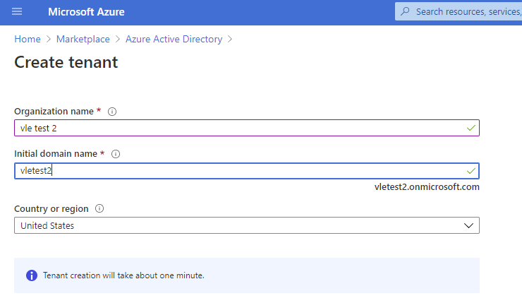
- After tenant is created, by clicking link for continue you will be navigated to Active directory Overview page where you need to navigate into B2C service
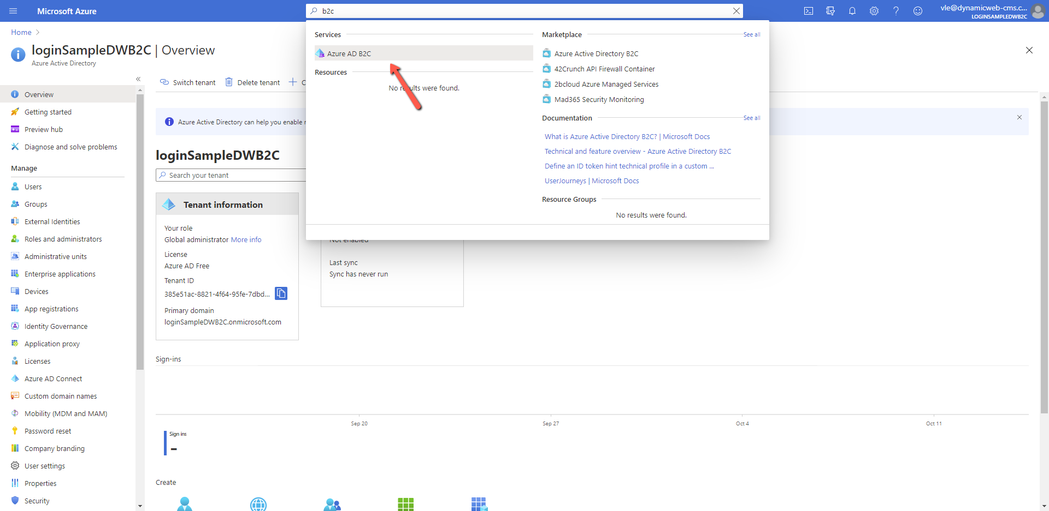
- Create Azure Active Directory B2C according to guide https://docs.microsoft.com/ru-ru/azure/active-directory-b2c/tutorial-create-tenant
- Set up Sign in/sign up user flow
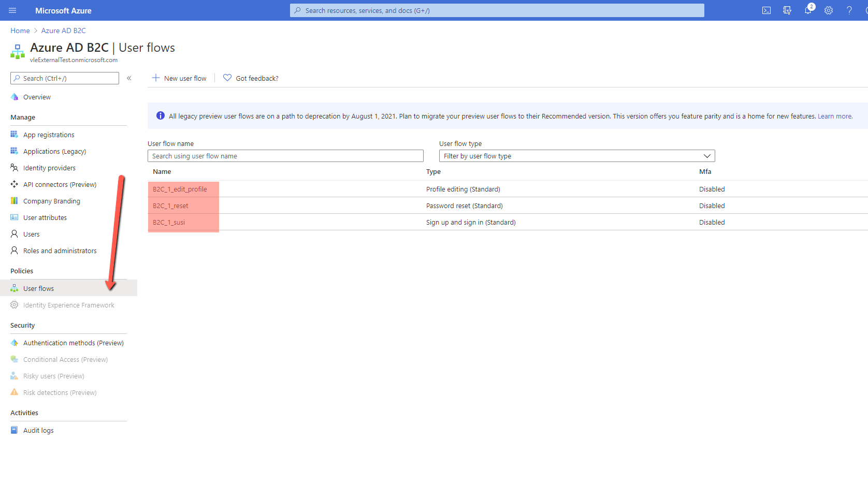
The name used at Dynamicweb provider as SignUpSignInPolicyId/EditProfilePolicyId/ResetPasswordPolicyId settings
Here you can create new or edit some specific flow.
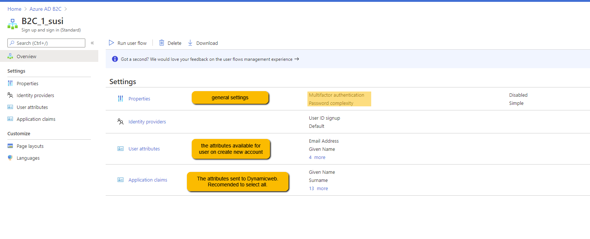
- Register an Application
The application registration is used to secure your directory by allowing only your applications to make requests and to make sure your users are sent to a trusted place after signing in.
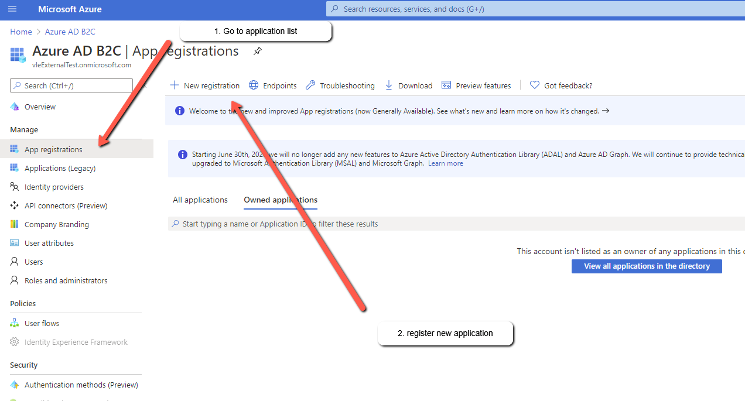
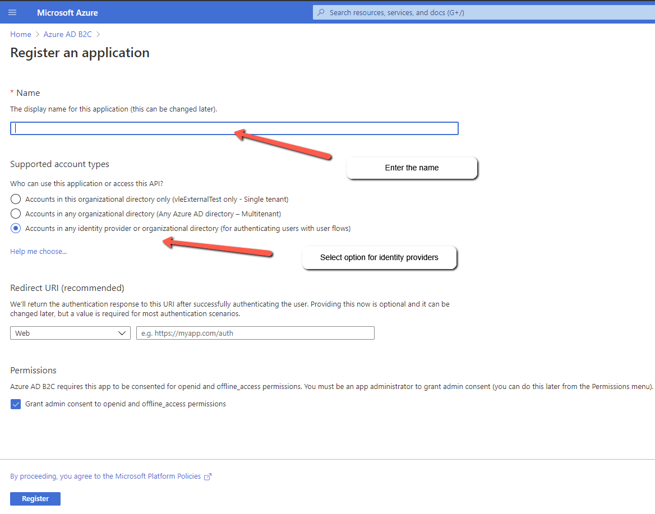
Once you created application, note down application and directory Ids – they will be used for Dynamicweb provider settings
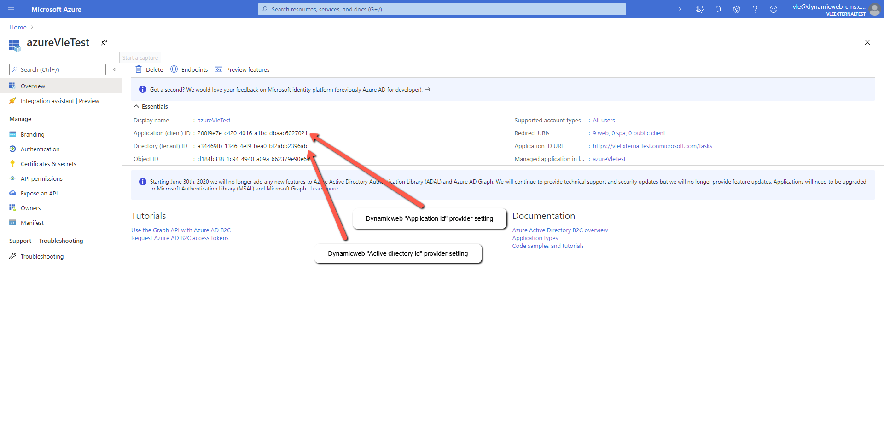
- Add you solution URIs for the application redirect URIs
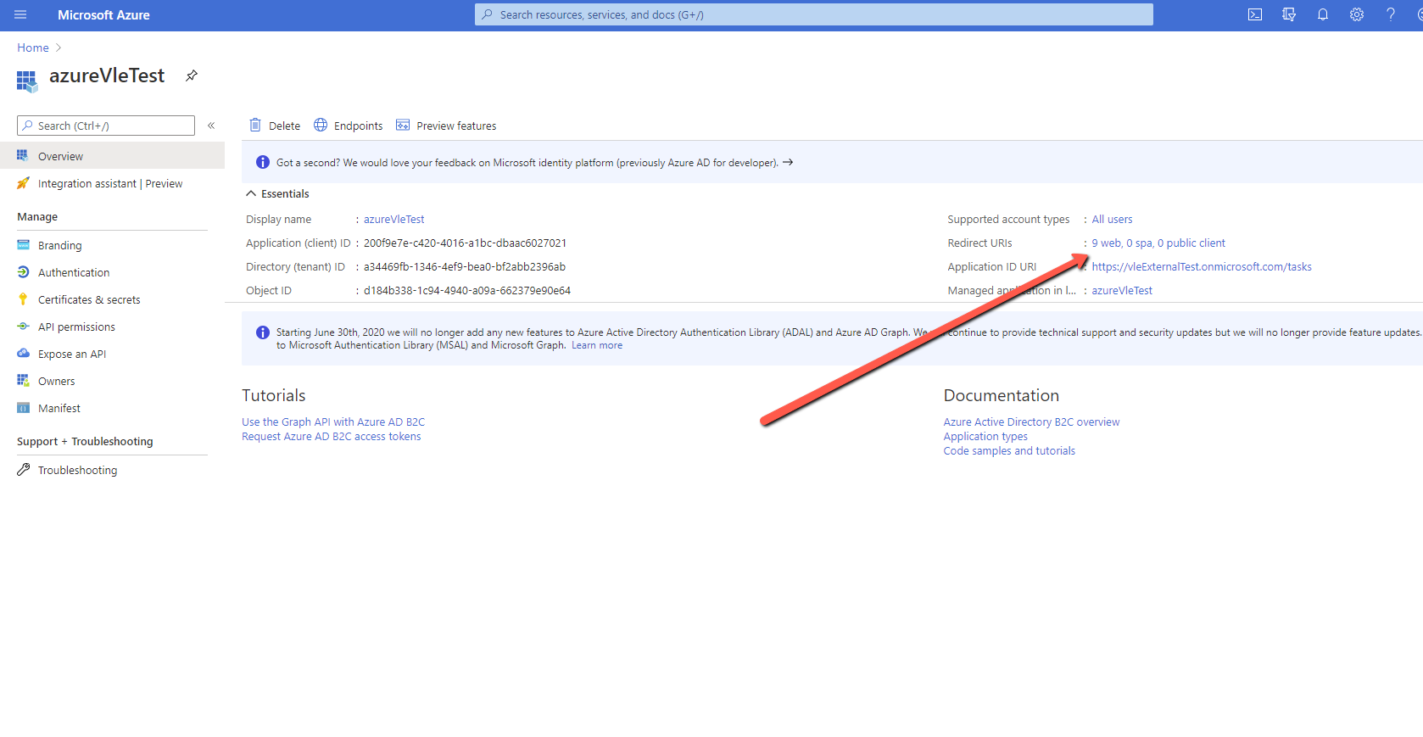
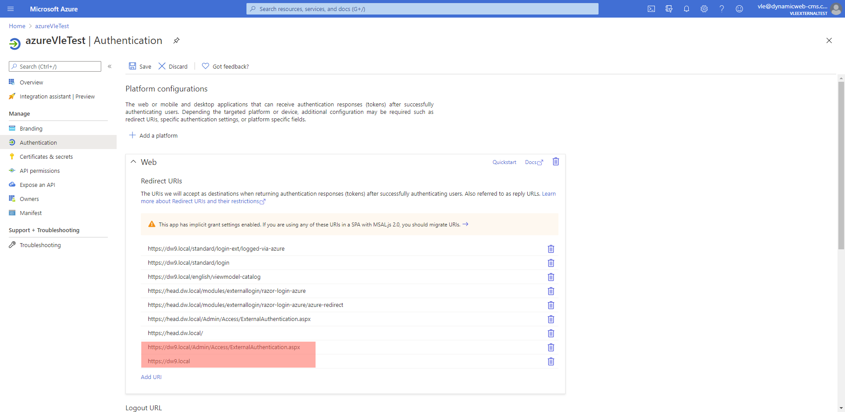
Where [dw9.local] should be your solution url
Also you need to scroll down the screen and make sure you have selected “ID tokens” option.
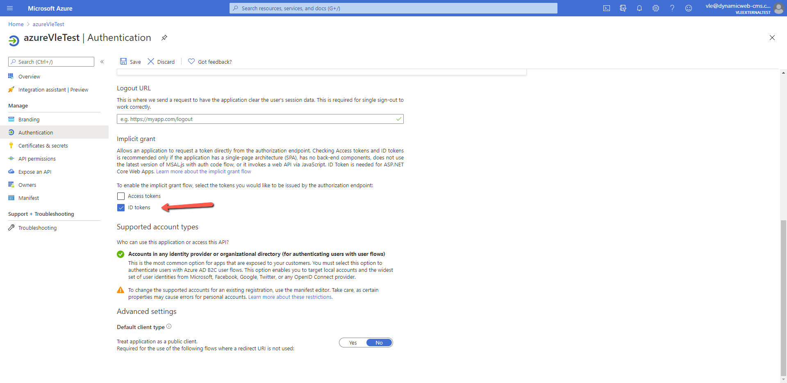
- Create and note down secret key, it is also required for Dynamicweb provider settings.
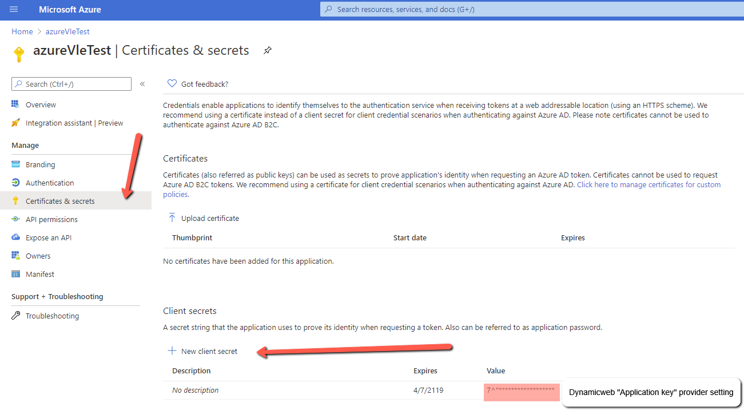

- For Admin login you need to add
https://[solution url]/Admin/Access/ExternalAuthentication.aspx

Additional provider functionality
From the Azure Active Directory B2C overview page you can go to user attributes list where you might add 2 custom user attributes works with Dynamicweb provider.
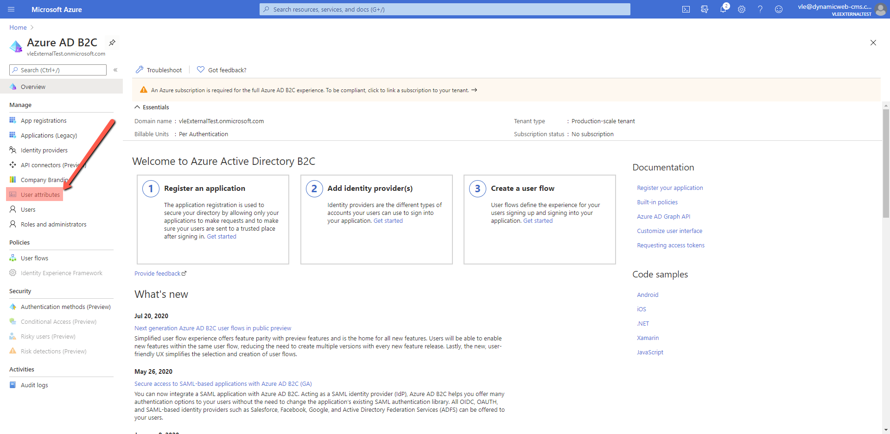
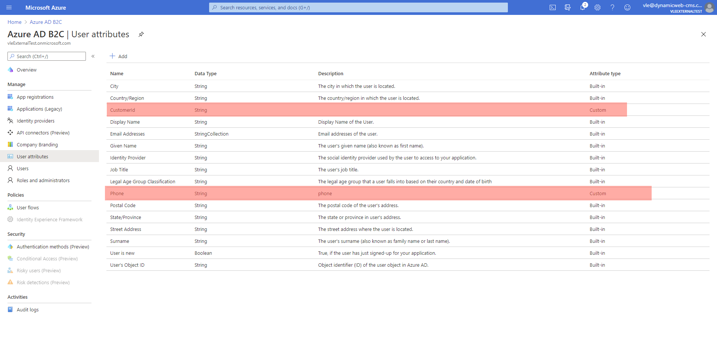
- Phone custom attribute. If you create phone attribute and set its name as Dynamicweb “Phone claim name” the Dynamicweb user phone will be filled with value set to the Azure phone user custom attribute.
- CustomerId custom attribute. If you create phone attribute and set its name as Dynamicweb “Customer impersonation id claim name”. On Azure user login Dynamicweb will try to find other users having user customer number equal to “CustomerId” from Azure and if there is found user, it will be set as “User I can set as secondary” for the one who logged in.

Set up Dynamicweb login provider
- Make sure your solution set using https due it is required for Azure.
- Enter required settings: tenant, directory id, application id, SignUpSignInPolicyId, application key from Azure portal.
- If you will change redirect page, you will need to add selected page url to the Azure application redirect URIs.
- If log out setting is not enabled, on frontend user logout azure will not be logout, so next login user will not be redirected to azure, but logged in immediately.
- Debug option is used for additional logging and troubleshooting.
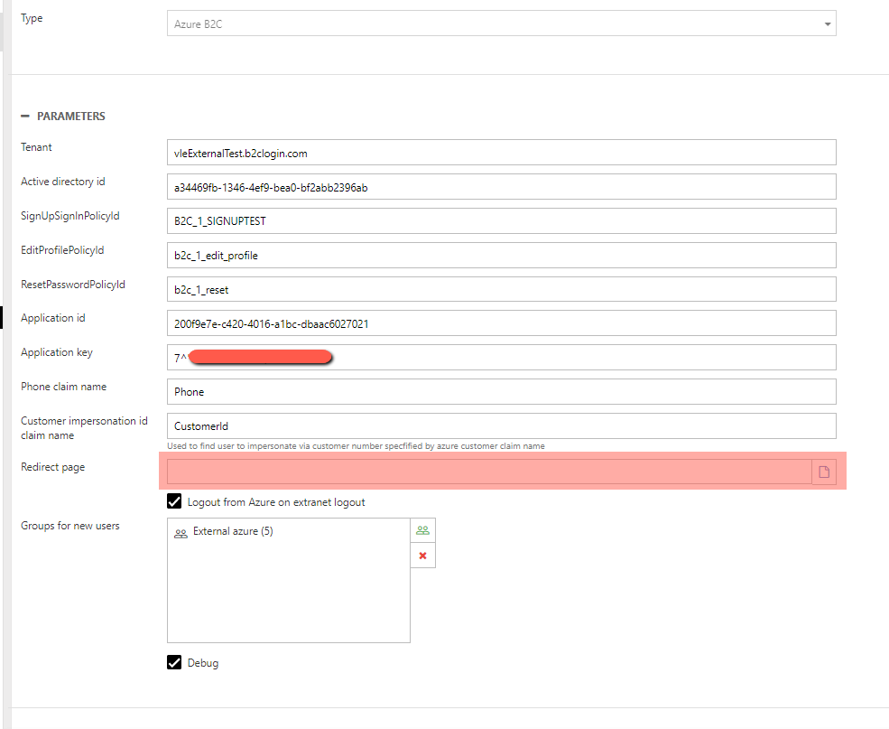
Please note that after you save provider you need to make an IIS reset for your solution so login provider will be registered on solution start.
EditProfilePolicyId and ResetPasswordPolicyId
EditProfilePolicyId and ResetPasswordPolicyId added to be run edit and reset password flow, but currently only availably from the provider API as:
- public static void Dynamicweb.Content.Social.Adapters.ExternalAuthentication.Azure.LoginProvider.EditProfile()
if there is logged in frontend user from Azure, provider will run edit policy.
- public static void Dynamicweb.Content.Social.Adapters.ExternalAuthentication.Azure.LoginProvider .ResetPassword(int providerId)
Provider with specified id will run reset password policy.

