Guide: 12 Steps to setup OAuth for Business Central endpoints and get access via Postman

1. Go to App registrations in Azure AD: 1
2. Create a New registration. 1
3. Copy the application (client) ID.. 2
4. Add API permission.. 2
5. Add a Client secret. 3
6. Add a Platform configuration.. 3
7. Open Postman. 4
8. Go to Authorization tab. 5
9. Click Get New Access Token. 5
10. Now input application (client) ID from step 3. and secret value from step 5. 5
11. Now click Request Token.. 6
12. When you receive the token, click Use token. 8
13. Optional: Copy/paste the token to https://jwt.io/. It can translate your token into this: 9

1. Go to App registrations in Azure AD:

2. Create a New registration.
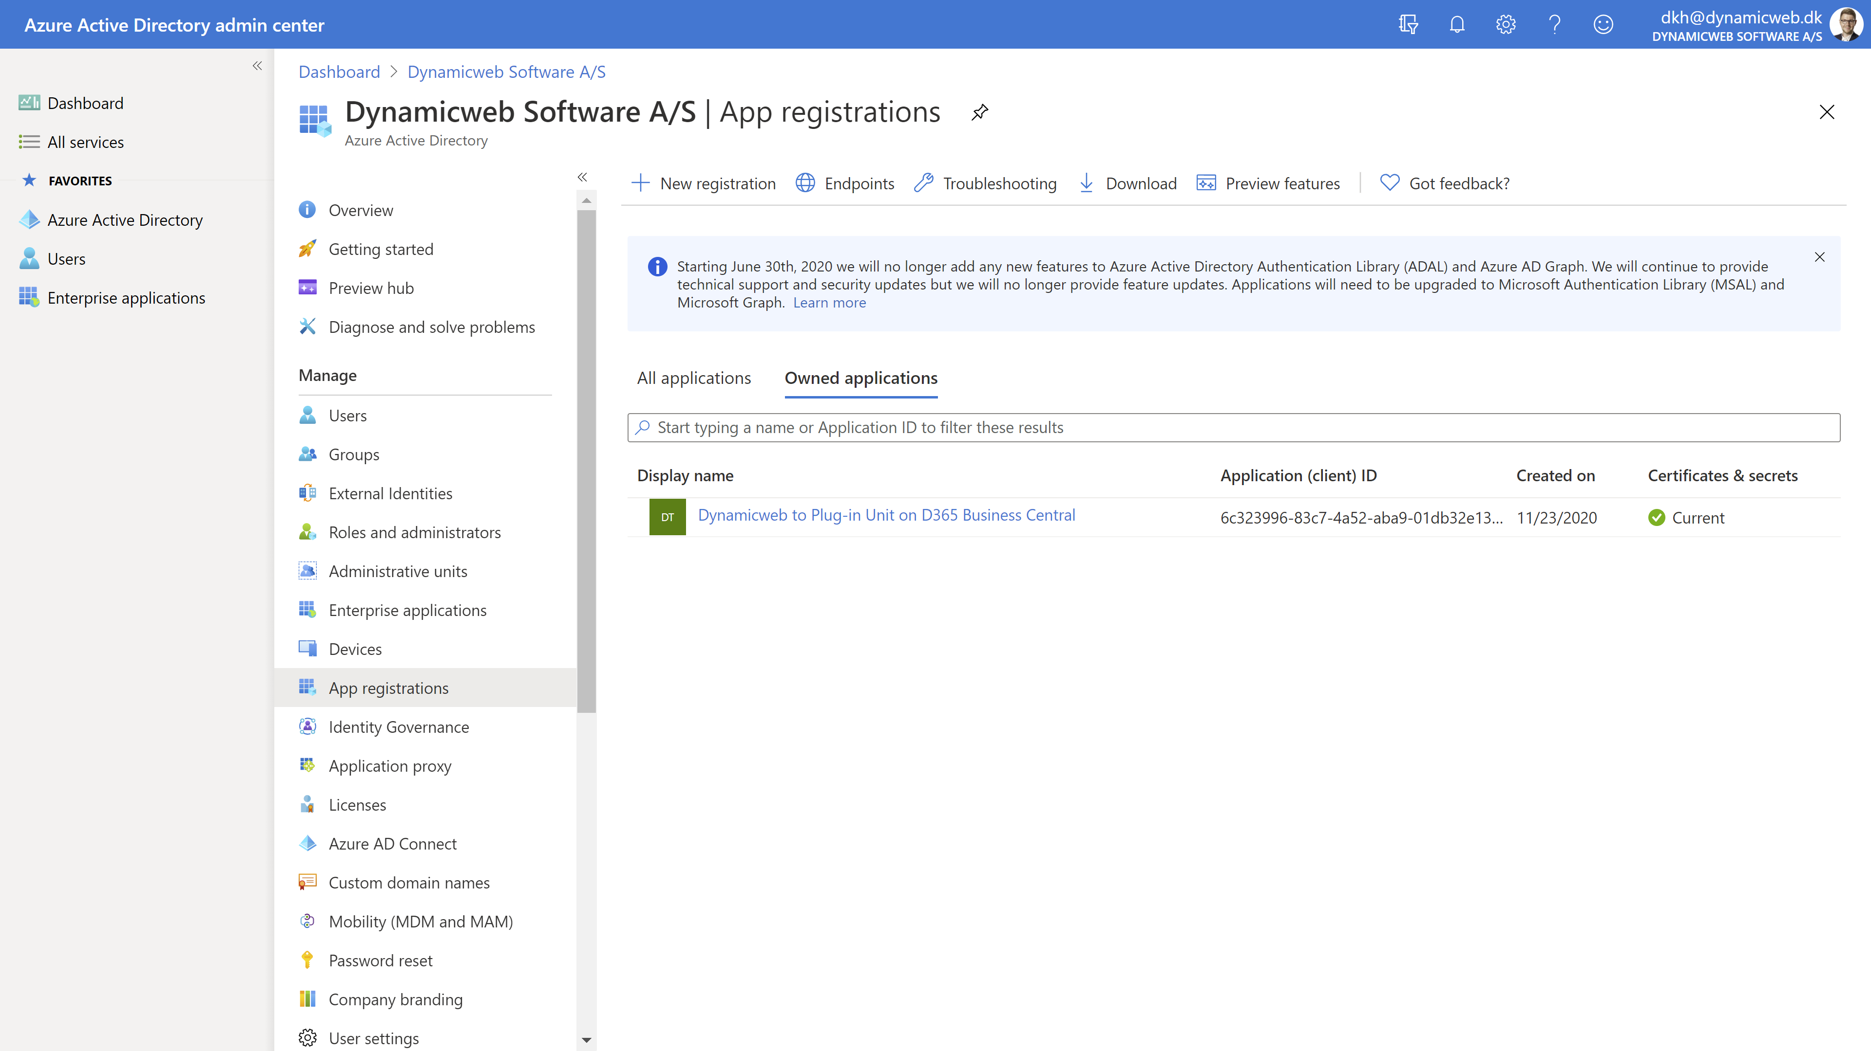

3. Copy the application (client) ID. Must be used later.
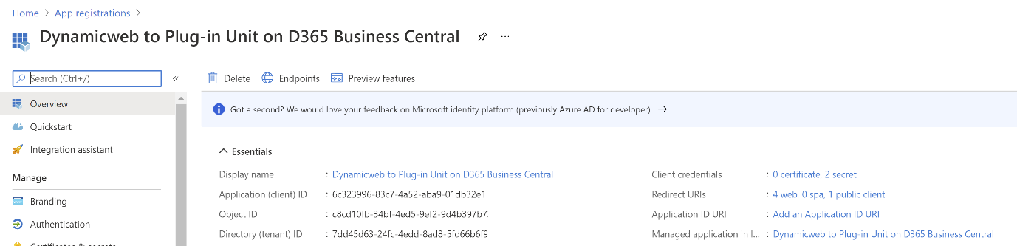

4. Add API permission. I set delegated permission for Dynamics 365 Business Central and then user_impersonation. Different settings might be needed for access by Dynamicweb integration framework, but for user access via Postman, my settings work.

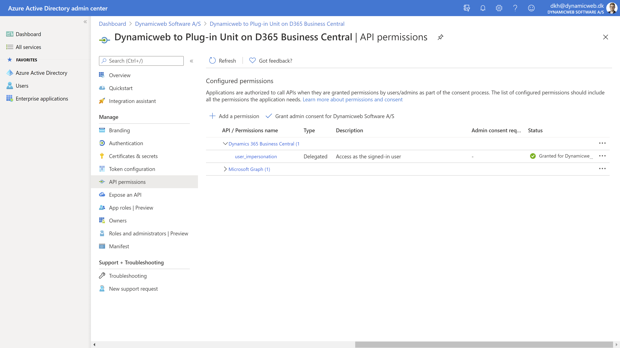

5. Add a Client secret. Copy the value. Must be used later and will never be shown again.
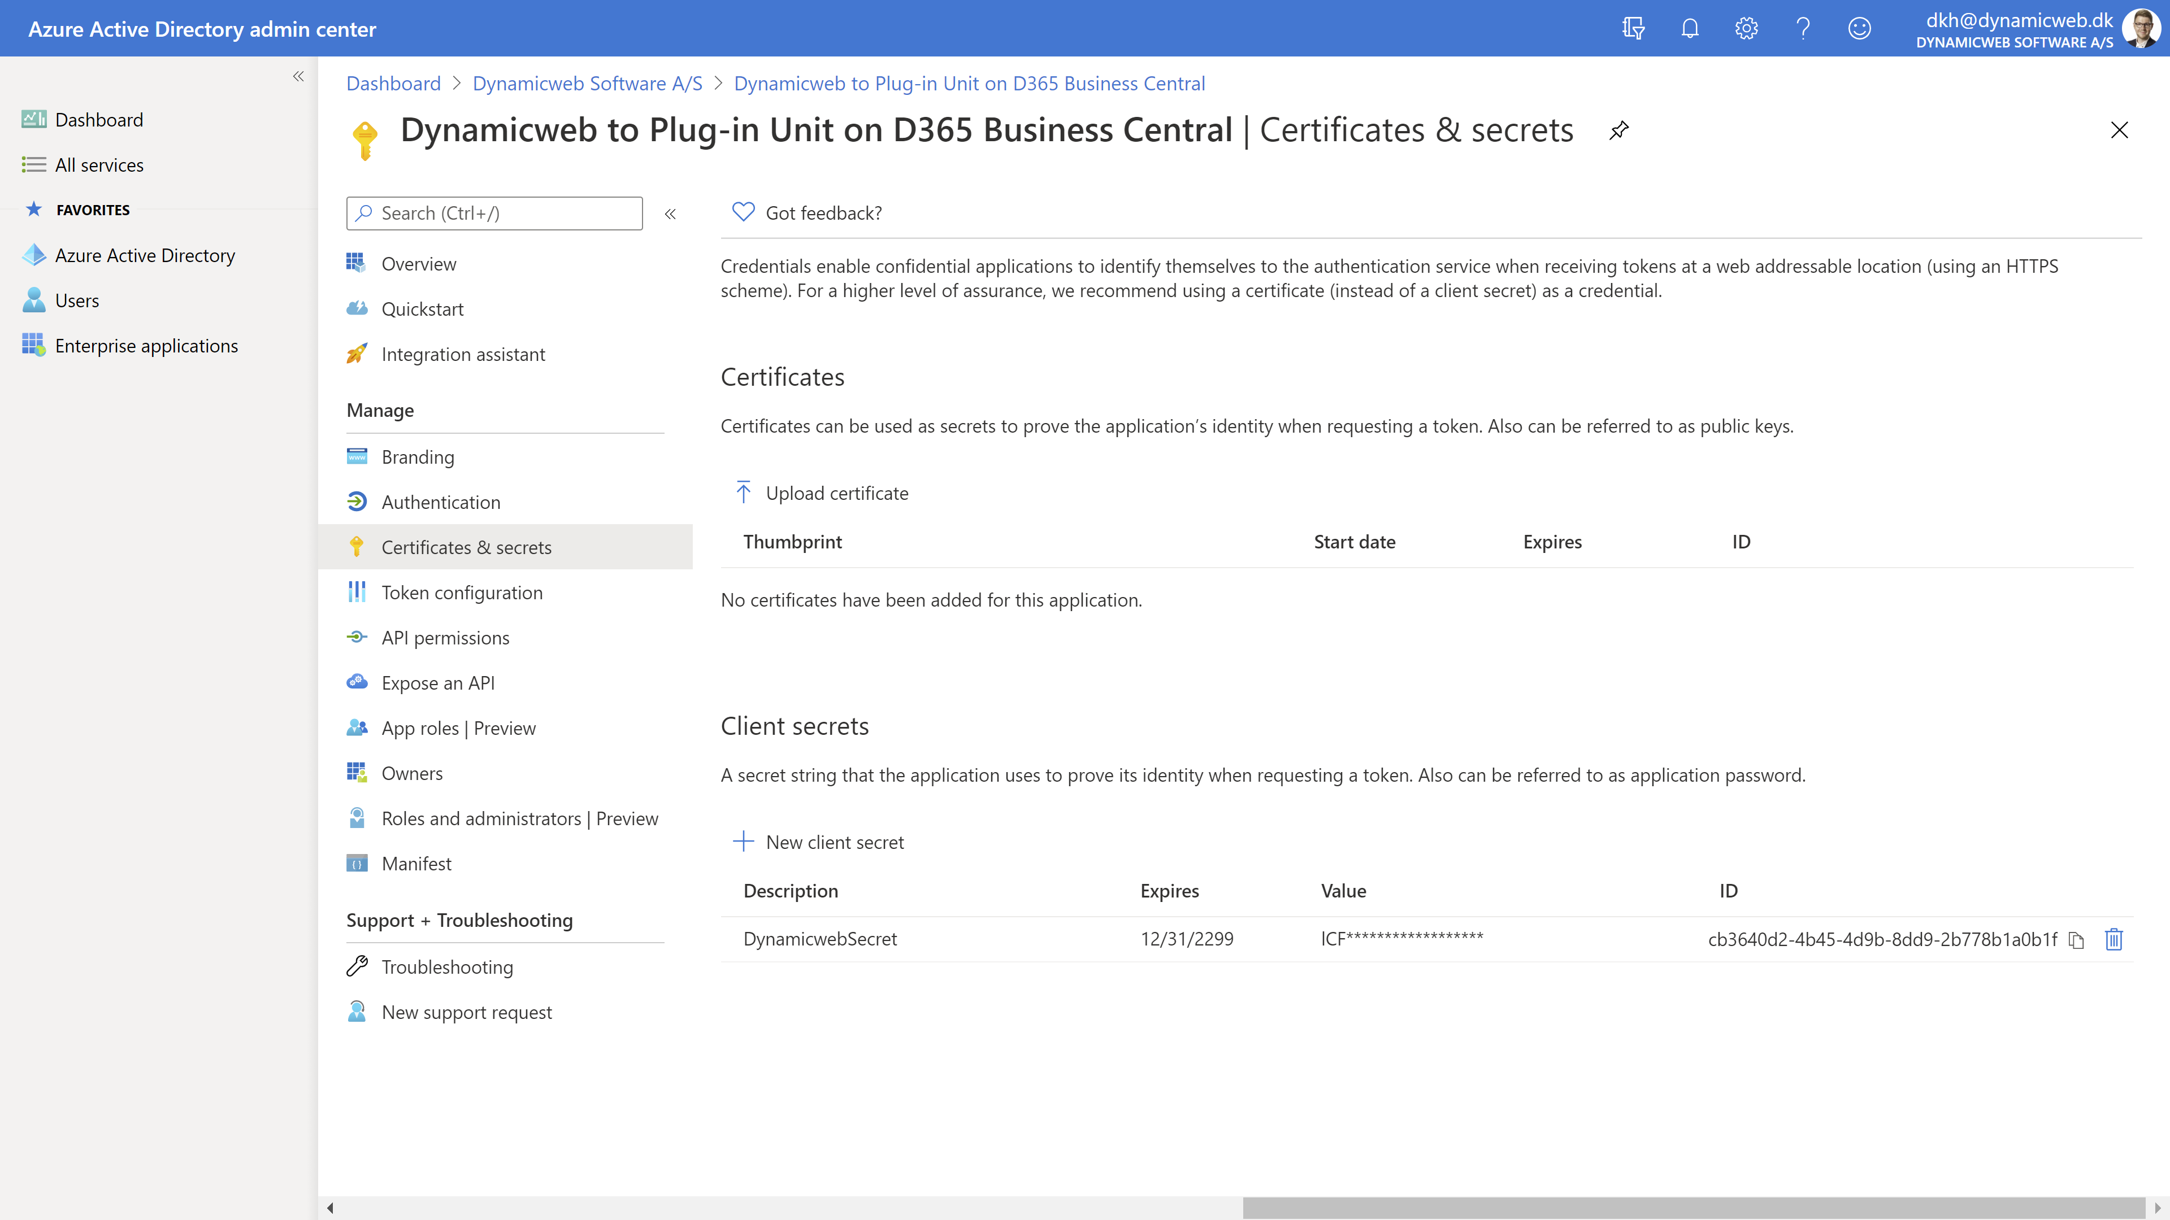

6. Add a Platform configuration. My settings are custom URL in Redirect URIs. I then copy a redirect URL supplied by Postman (will show later). Different settings might be needed for access by Dynamicweb integration framework, but for user access via Postman, my settings work.
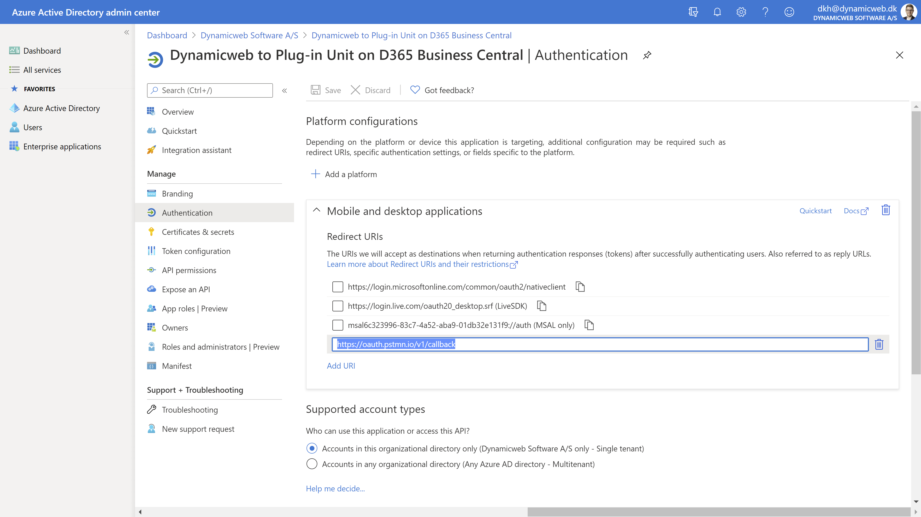

7. Open Postman. Create a new request and add an endpoint from BC which you would normally access with basic authentication.

Example: https://api.businesscentral.dynamics.com/v2.0/{tenant_ID}/BC17/api/v2.0/companies(0f8058e0-affd-ea11-bb48-000d3a2fece2)/items
Please note that the tenant ID can be omitted. It will be part of the received token.
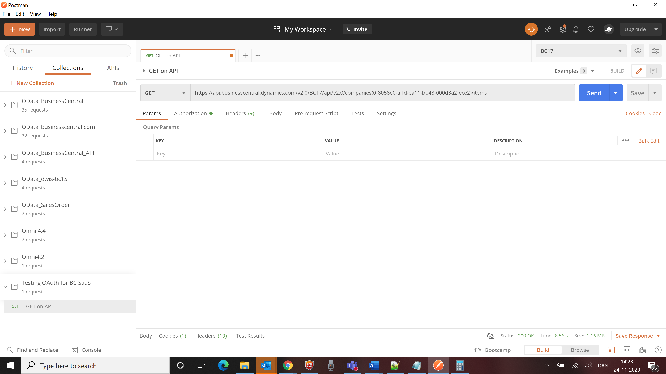

8. Go to Authorization tab. Choose Type OAuth 2.0 and Add authorization data to: “Request Headers”
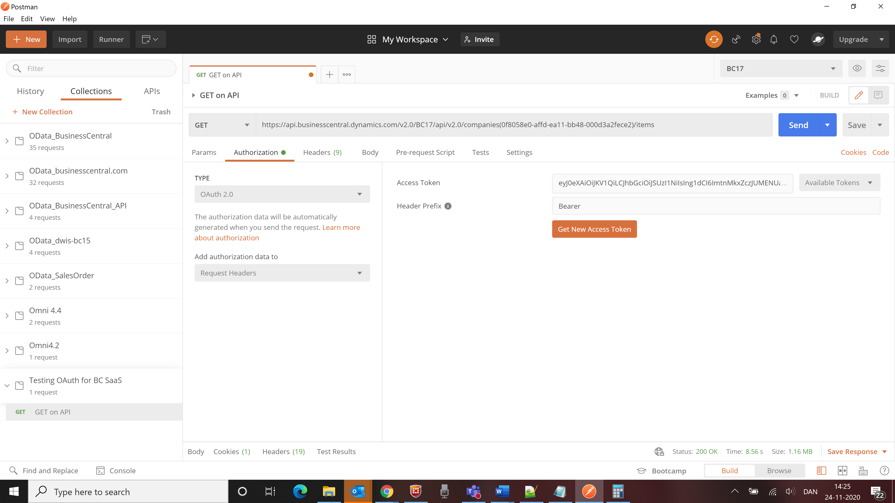

9. Click Get New Access Token (the big orange button).

10. Now input application (client) ID from step 3. and secret value from step 5. Also input everything else as shown in the screen shot below.
- For Auth URL use: https://login.windows.net/7dd45d63-24fc-4edd-8ad8-5fd66b6f9733/oauth2/authorize?resource=https://api.businesscentral.dynamics.com
- For Access Token URL use: https://login.windows.net/7dd45d63-24fc-4edd-8ad8-5fd66b6f9733/oauth2/token?resource=https://api.businesscentral.dynamics.com
Please note that the tenant ID is needed in these URLs.
- Postman will provide a Callback URL which you must use in step 6. above. Dynamicweb obviously needs to supply its own callback URL, but in this document I simply get it to work with Postman.
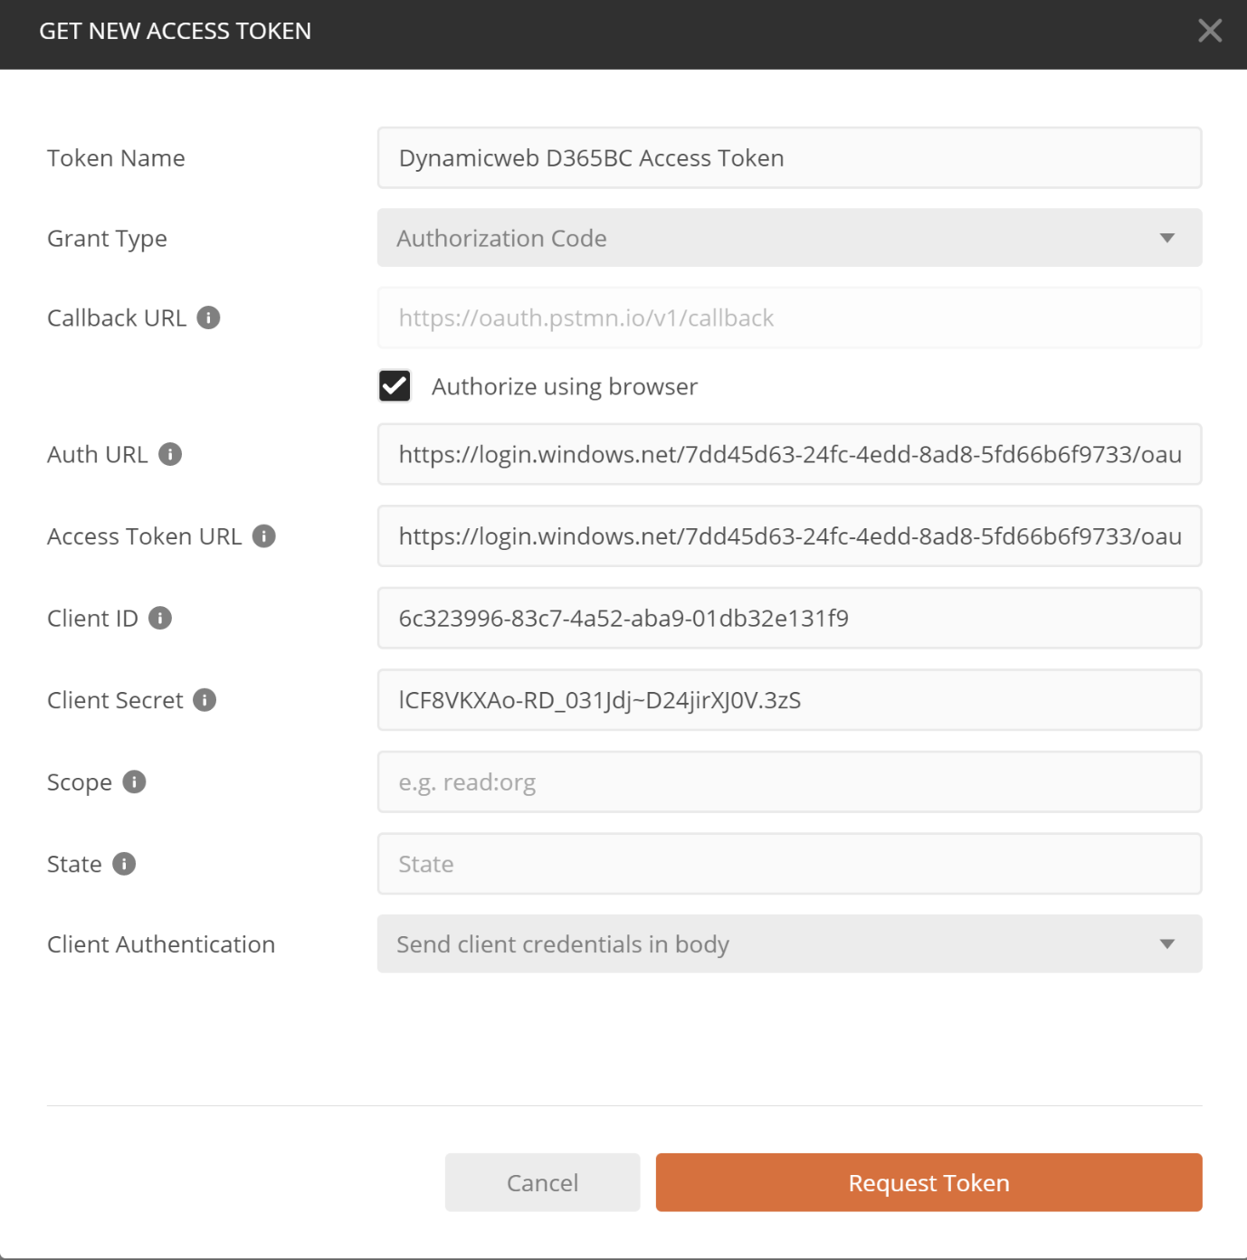

11. Now click Request Token. You will be taken to a browser page. Type in your Azure AD credentials.
Please note that you should allow popups because you will now be redirected back to Postman.
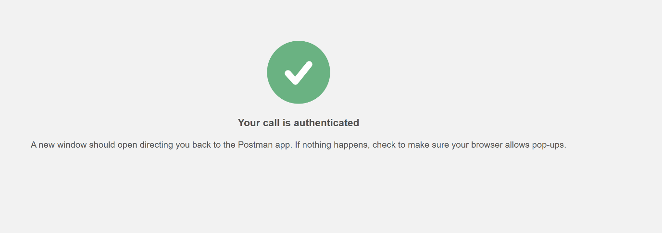
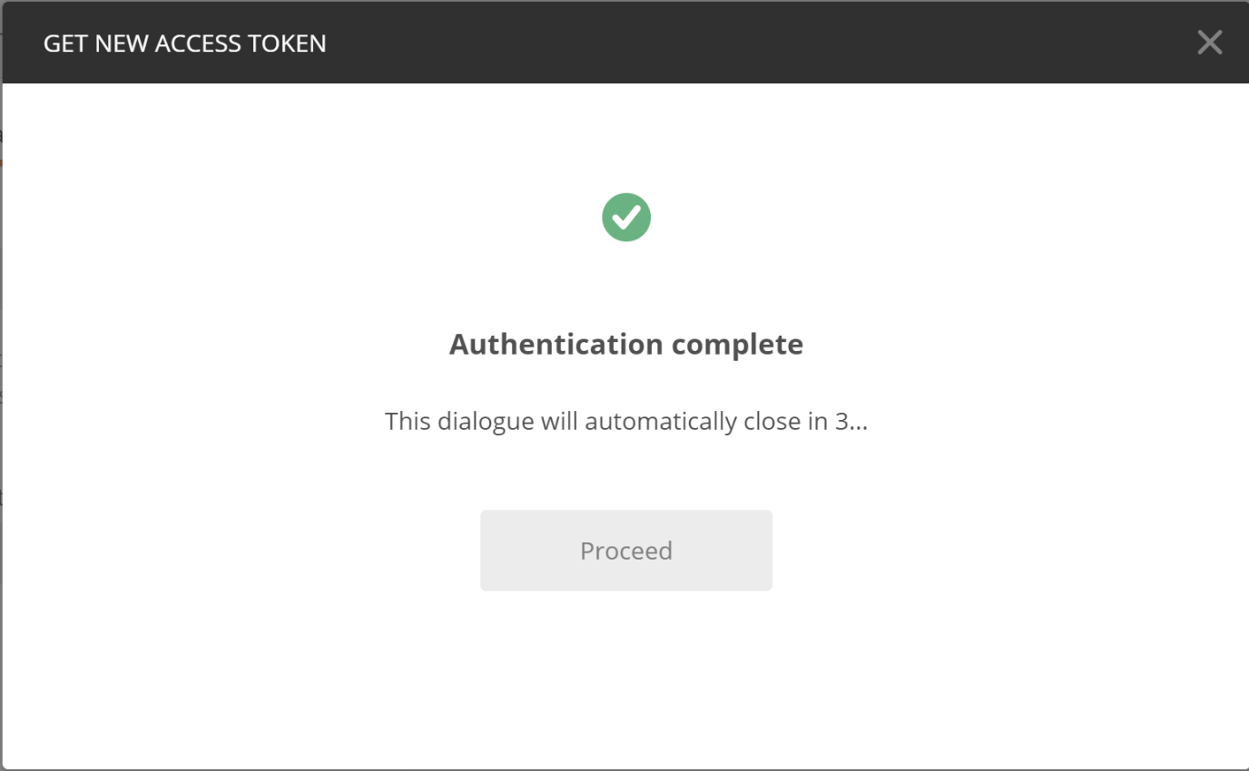

12. When you receive the token, click Use token.
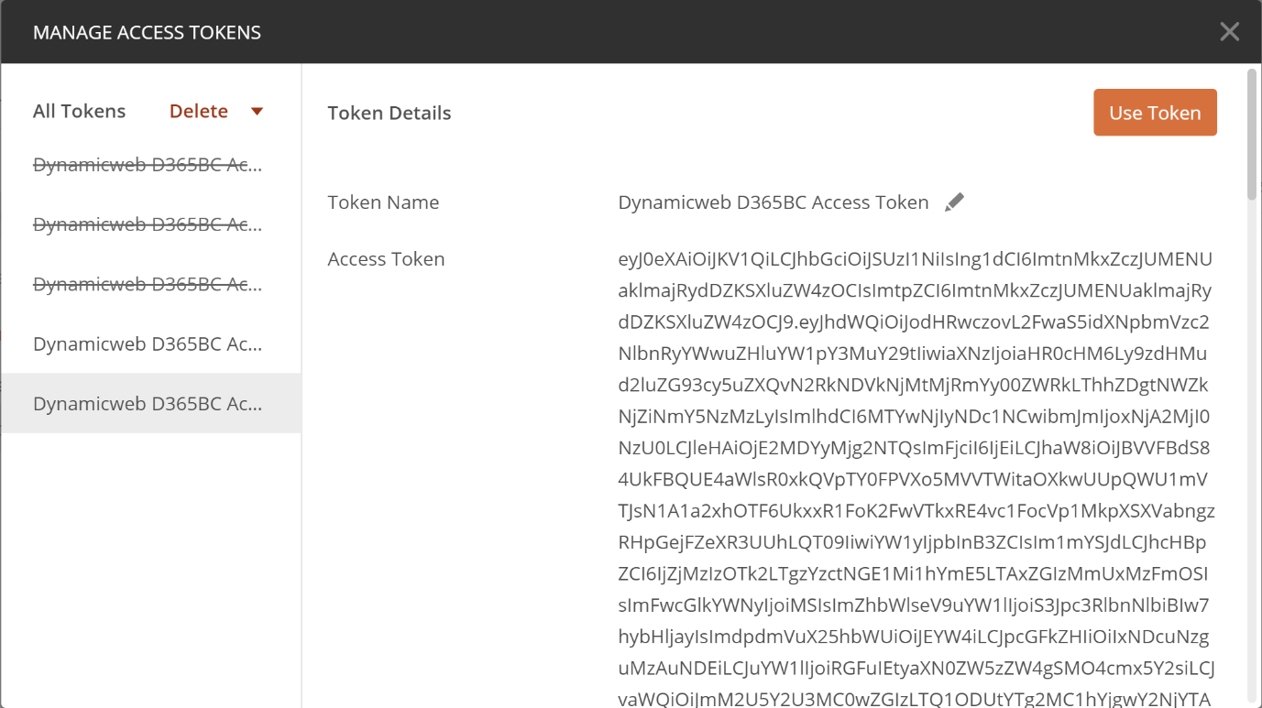

13. Optional: Copy/paste the token to https://jwt.io/. It can translate your token into this:
