Dynamicweb | LS Retail Setup Guide

Revisions
Date | Author | Version | Comment
JAN-22-2021 | DKH | 1.00 | First version for ReleasePackage.17.4.13.9.10.3.4.2

Contents
Target Platforms 1
Initial Steps 2
Installation Steps 3
Setup Steps 4
Setup Completed: Next steps 5
Verify the following 5
Appendix: Setup steps screen shots 6
Table of screen shots and direct hyperlinks 6
Appendix: Known issues 15

Target Platforms
- LS Central 17.0
- LS Omni 4.13
- Dynamicweb 9.10
- Rapido 3.4

Initial Steps
- Download database bacpac file from https://doc.dynamicweb.com/rapido/download
Download “rapidocontentecom-20201103-database.zip” (Rapido Only Pages & Ecommerce Content, No Products)
- Download Dynamicweb from https://doc.dynamicweb.com/downloads/releases
Download “Application(DW910).zip” or “Application(9.10.0).zip”
- Download LS.Retail.DW.Files.17.0.4.13.9.10.3.4.2.zip
Contains Dynamicweb Files folder with Rapido 3.4.2 custom templates.
- Download LS.Retail.DW.Bin.17.0.4.13.9.10.3.4.2.zip
Contains binary files LSRetailIntegration.dll and LSRetailIntegration.pdb
- Setup LS Central and LS eCommerce service (LS Omni). Have the URL ready.
This guide uses “VM_LSCentral_170_B29” with LS Central 17.0 and Omni 4.13 downloaded from https://portal.lsretail.com/Products/LS-Nav/Downloads (partner access required).

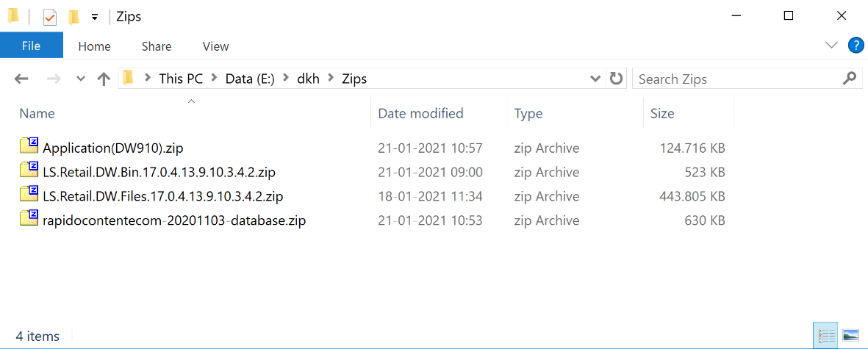
All needed files downloaded. Except the LS VM (step e.) which is a separate guide.

Installation Steps
- Open SQL Server Management Studio (SSMS)
- Right click the Databases folder and click “Import Data-tier Application…”.
- Select the bacpac file (step a.) and create a new database.
- Make sure there is a SQL user with needed database role memberships. Either create your own user from scratch or follow these optional steps:
- (Optional) Go to the Security folder of the new database and delete user: qa
- (Optional) Go to the Logins folder of the new database and find existing qa user.
- (Optional) Edit the existing qa user and open the User Mapping tab. Make sure existing qa user is mapped to the new database (step 1.) and that qa user has needed database role memberships (owner, writer etc.)
- Create a new website in Internet Information Services (IIS) and link its Physical Path to the application folder of the downloaded Dynamicweb (step b.). If you need a guide to setup Dynamicweb on IIS, please read this: https://doc.dynamicweb.com/get-started/introduction/installation/installing-dynamicweb
- Add a Virtual Path with alias Files and point it to the Files folder you downloaded (step c.)
- Open the bin folder and copy/paste the files: LSRetailIntegration.dll and LSRetailIntegration.pdb (step d.). See screen shot 1. on page 6.
- Edit the GlobalSettings.aspx file and point the database to the new database (step 1.)
- Open the website in a browser and use base URL + “/Admin” to setup the site in the Dynamicweb backend.

Setup Steps
- Before you can properly access Dynamicweb (step 10.), you must install license or get a free trial (see 2. “Installation of license or use of free trial.” on page 7.)
- Go to Settings -> Ecommerce -> Product catalog -> Shops. Create a new shop. This is the shop that will be associated to the web store in LS Central. See screen shot 3. on page 7.
- Go to Settings -> Integration -> Data Integration -> LsDataImport -> Edit destination settings. Set shop to the shop you just created. See screen shot 6. on page 9.
- Go to Settings -> Integration -> Integration Framework Batch -> LsRetail Import data. Point LS eCommerce service URL to Omni URL from step e. If the connection is a success, you can select the web store in LS Central in the Store dropdown.
Set Destination shop to the shop you just created. Then set the following (or see screen shot 7. on page 9):
- Product import activity to “LsDataImport”
- User import activity to “None”
- Store import activity to “None”
- Uncheck all checkboxes
- Check checkbox “Import Currencies”
- Save and run the batch job. You now have currencies from LS Central.
- Open the batch job again and set the following(or see screen shot 8. on page 10):
  - Product import activity to “LsDataImport”
  - User import activity to “LsUserIntegration”
  - Store import activity to “LsStoreImport”
  - Check all checkboxes
  - Set LCY currency to “British Pound” (if British Pound is the LCY of the LS Central in step e.)
- Save the batch job.
- Go to Settings -> Integration -> Integration Framework Live -> LS Retail Live Integration. Point Web service URL to Omni URL from step e. Select the same Store and Destination Shop as you did in the two previous steps. See screen shot 9. on page 10.
- Go to Content -> Edit -> Ecommerce. Set Shop, Language, Currency, Country, Prices with VAT, Stock location etc. as needed. Most importantly set Shop to the shop you just created. See screen shot 11. on page 11.
- Go to Content -> Products page -> Properties -> Options -> Navigation. Set In shop to the shop you just created. See screen shot 12. on page 12.
- Go to Content -> Cart -> Cart page -> Content -> App -> Shop. Set Shop to the shop you just created. See screen shot 13. on page 12.
- Go to Edit Website -> LS Retail. Click Initialize site. See screen shot 14. on page 13.
- Go to Content -> Rapido system tools -> Feeds -> Mini cart (JSON) -> Cart -> App. Set Shop to the shop you just created. See screen shot 15. on page 13.
- Go to Settings - > Control Panel -> External Authentication -> LS Retail Login. Set Web service URL to Omni URL from step e. See screen shot 16. on page 14.
- Go to Settings -> Integration -> Integration Framework Batch -> LsRetail Import data. Run it. Now all users, stores, products, images are imported. See screen shot 17. on page 14.
- (Optional) If you want to allow Dynamicweb to handle credit card by sending preapproved payment tokens into LS Central and receive credit card capture instructions from LS Central when orders are shipped, then please revisit screen shot 9. on page 10. It shows how you can enable this with a checkbox setting and by defining how many days LS Central may wait to invoice and capture payment in accordance with the rules of the payment gateway provider.

Setup Completed: Next steps
When you have completed all steps above, you will have turned a plain Dynamicweb and plain Rapido into a LS Retail-integrated solution. The initialize site action and batch import will have created needed pages, forms, settings, user groups, product groups, custom user/product/order fields, basic payment and shipping providers and external login provider. Please verify this before proceeding with a demo or test of the solution.

Verify the following
- Imported users in area: Users
- Imported product groups and products in area: Ecommerce -> Shop
- Imported stores in area: Content -> LS Stores
- Imported discounts in area: Ecommerce -> Discounts & Offers -> Product discounts
- Payment provider in area: Settings -> Ecommerce -> Orders -> Payment
- Shipping provider in area: Settings -> Ecommerce -> Orders -> Shipping
- External authentication in area: Settings -> Control Panel -> External Authentication
- LS recipient provider in area: Marketing -> Email Marketing - > New Campaign -> Recipient Provider
- (Optional) If took the optional step to allow Dynamicweb to handle credit card payments then please make sure that LS Central and Omni are setup to do so. The full guide on how to do this is published by LS Retail in the document: LS Omni 4.x Unified Commerce Interface Developers Guide.pdf.
You are now ready to proceed with the Demo Guide.

Appendix: Setup steps screen shots

Table of screen shots and direct hyperlinks
1. Copy/paste LSRetailIntegration.dll and LSRetailIntegration.pdb to bin folder.
2. Installation of license or use of free trial.
3. Settings -> Ecommerce -> Product catalog -> Shops. Create a new shop.
4. Settings -> Integration -> Data Integration.
5. Settings -> Integration -> Data Integration -> LsDataImport.
6. Settings -> Integration -> Data Integration -> LsDataImport -> Destination settings. Setup Shop.
7. Settings -> Integration -> Integration Framework Batch -> LsRetail Import data. Import Currencies.
8. Settings -> Integration -> Integration Framework Batch -> LsRetail Import data. Setup and Save.
9. Settings -> Integration -> Integration Framework Live -> LS Retail Live Integration.
10. Content -> Edit.
11. Content -> Edit -> Ecommerce. Set Shop, Language, Currency, Country, Prices with VAT, Stock location etc.
12. Content -> Products page -> Properties -> Options -> Navigation. Setup Shop.
13. Content -> Cart -> Cart page -> Content -> App -> Shop. Setup Shop.
14. Edit Website -> LS Retail - > Initialize site.
15. Content -> Rapido system tools -> Feeds -> Mini cart (JSON) -> Cart -> App. Setup Shop.
16. Settings -> Control Panel -> External Authentication -> LS Retail Login.
17. Last action, run the batch import.

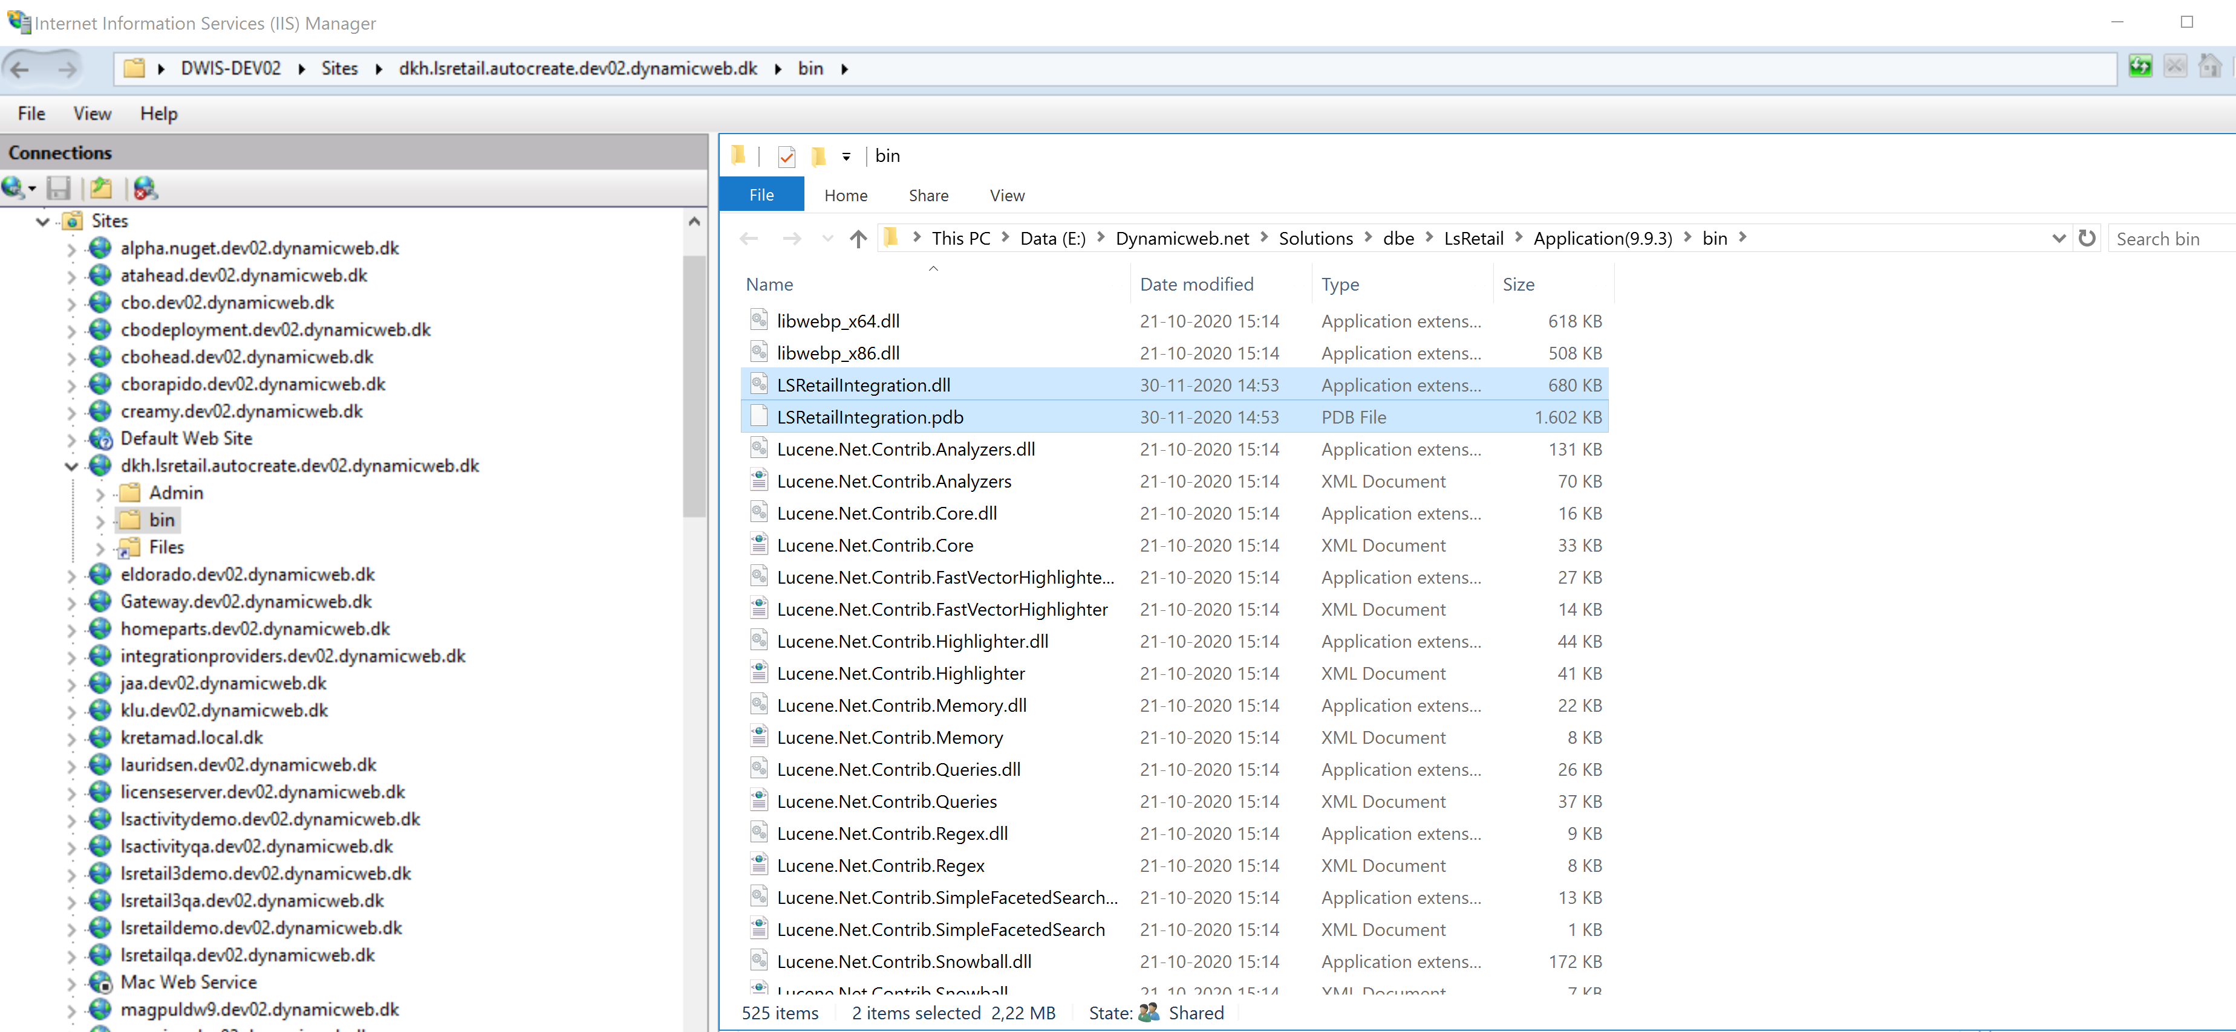
1. Copy/paste LSRetailIntegration.dll and LSRetailIntegration.pdb to bin folder.

2. Installation of license or use of free trial.
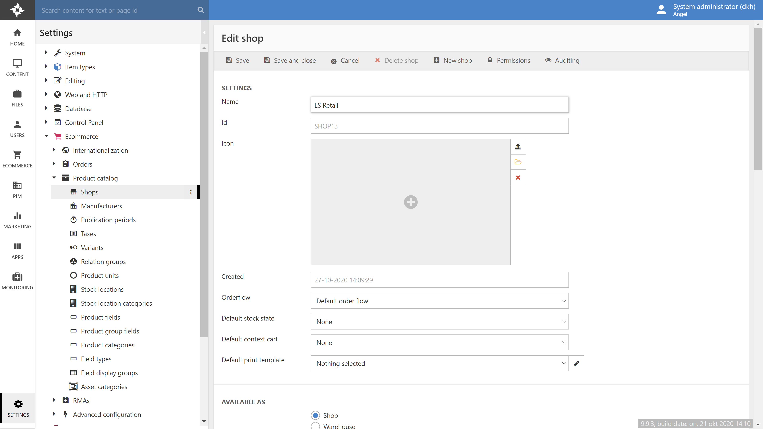
3. Settings -> Ecommerce -> Product catalog -> Shops. Create a new shop. In this example the shop is named LS Retail.

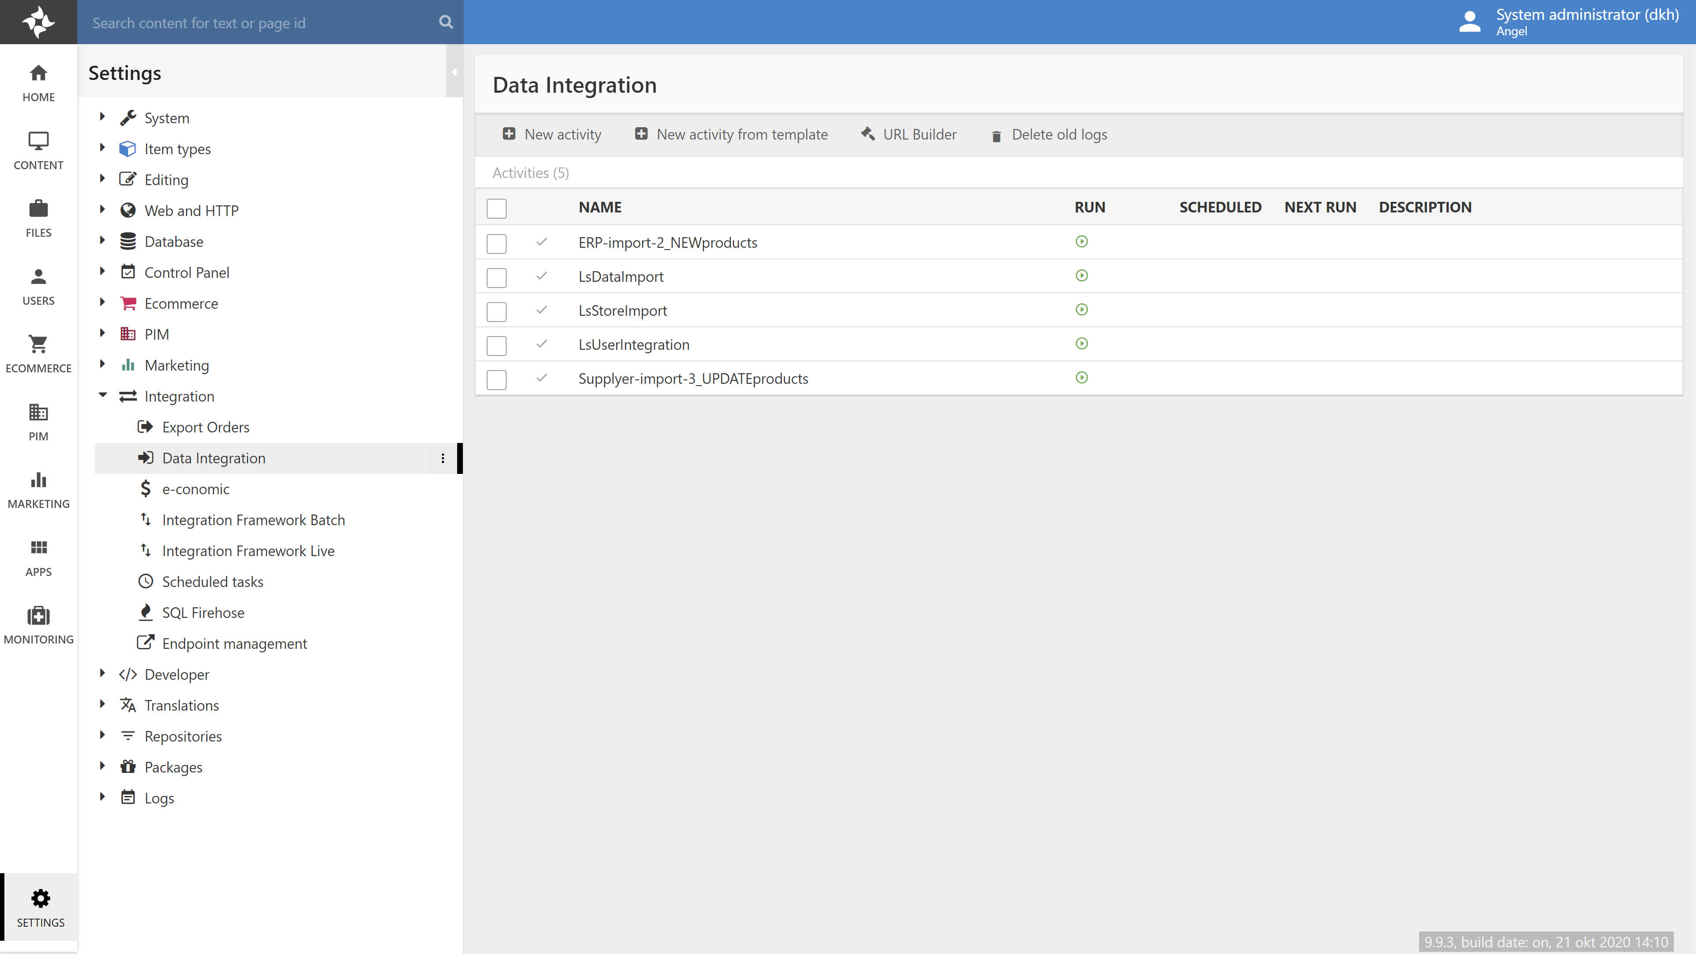
4. Settings -> Integration -> Data Integration.
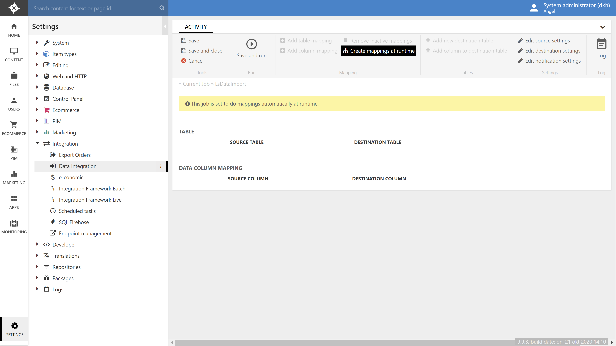
5. Settings -> Integration -> Data Integration -> LsDataImport.
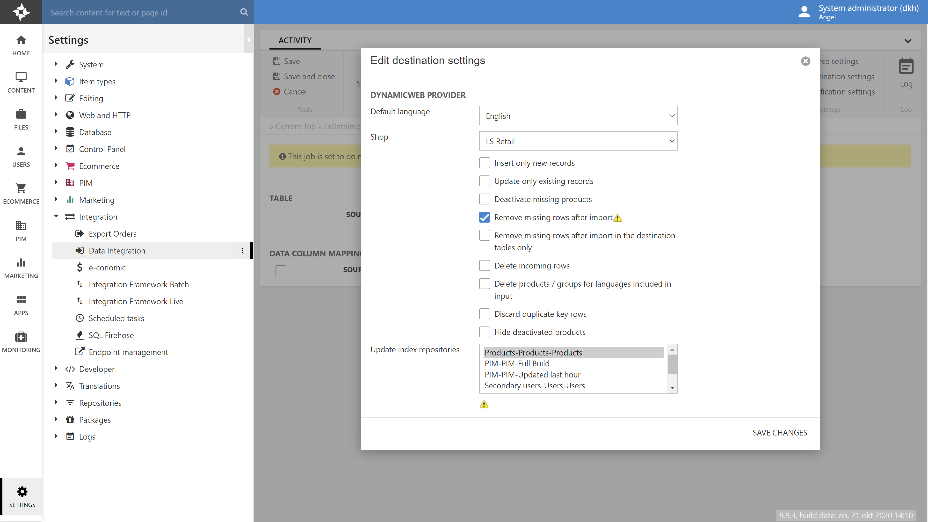
6. Settings -> Integration -> Data Integration -> LsDataImport -> Destination settings. Set Shop to the shop you created in step 4. on page 4.
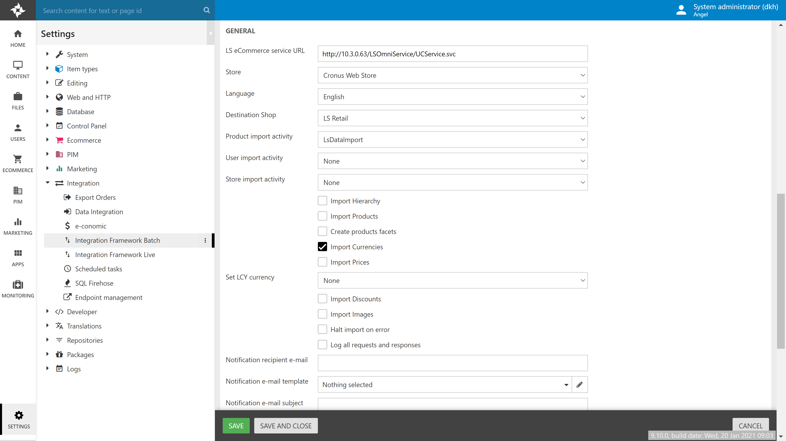
7. Settings -> Integration -> Integration Framework Batch -> LsRetail Import data. Point LS eCommerce service URL to Omni URL in step e. If the connection is a success, you can find the LS web store in the Store dropdown. Then import currencies before proceeding.
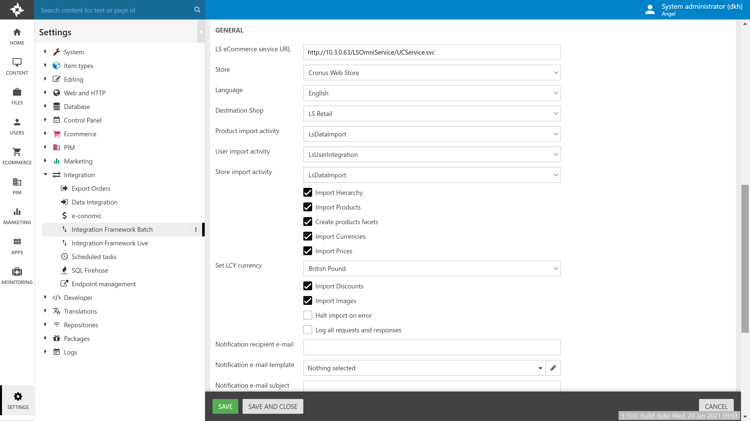
8. Settings -> Integration -> Integration Framework Batch -> LsRetail Import data. Point LS eCommerce service URL to Omni URL in step e. If the connection is a success, you can find the LS web store in the Store dropdown. Check all checkboxes and set LCY currency.
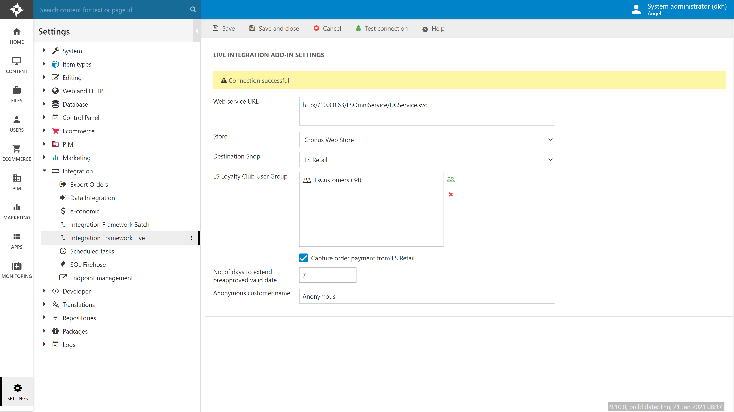
9. Settings -> Integration -> Integration Framework Live -> LS Retail Live Integration. Point Web service URL to Omni URL from step e. Select the same Store and Destination Shop as you did in the previous step.
Please note: In this example the Anonymous customer name is set to ‘Anonymous’. Whichever text value you use, you need to make sure that this customer exists as a member in LS Central. Otherwise, create it in LS Central.
This example is also setup to capture order payments from LS Central and to allow 7 days before preapproved credit card reservations become invalid. Both of these settings assumes that LS Central and Omni is setup to receive preapproved payment tokens and send it back into /dwapi/lspayments.
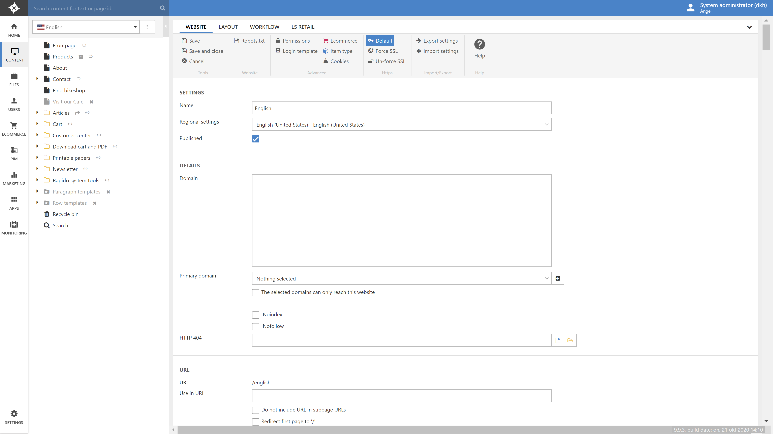
10. Content -> Edit.
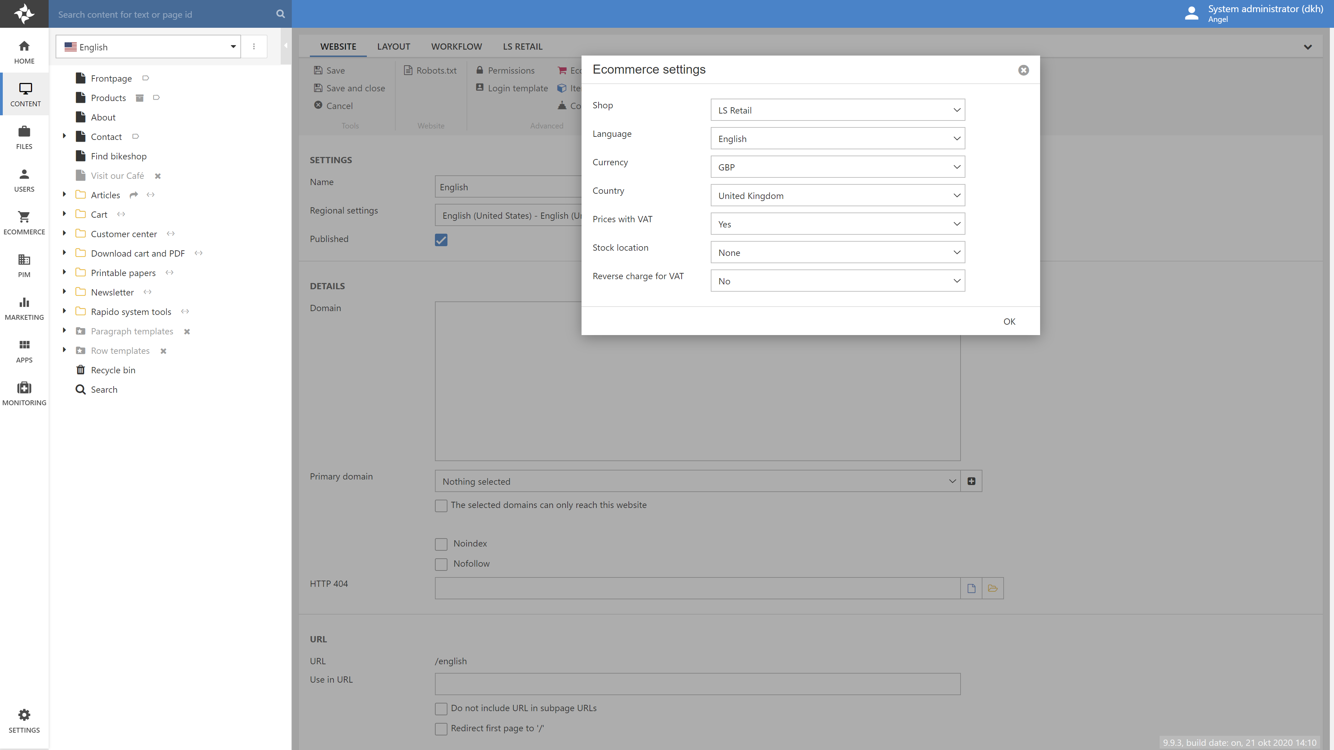
11. Content -> Edit -> Ecommerce. Set Shop, Language, Currency, Country, Prices with VAT, Stock location etc.
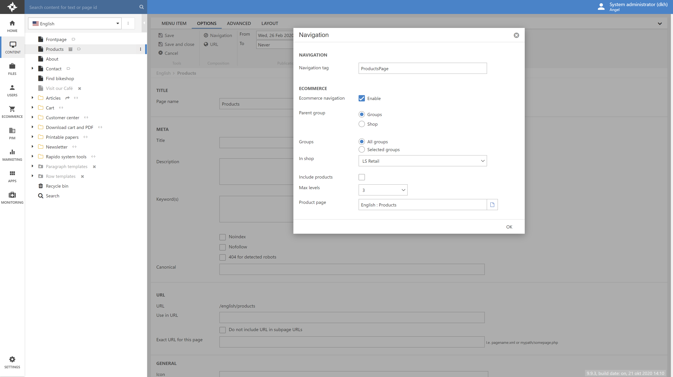
12. Content -> Products page -> Properties -> Options -> Navigation. Set In shop to the shop you used in previous steps.
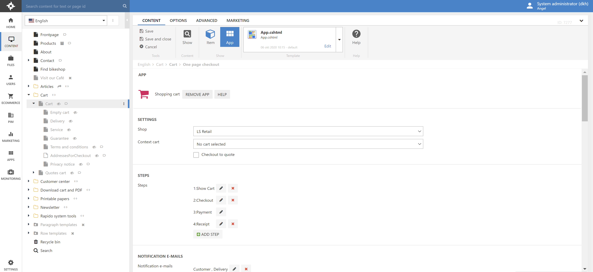
13. Content -> Cart -> Cart page -> Content -> App -> Shop. Set Shop to the shop you used in previous steps.
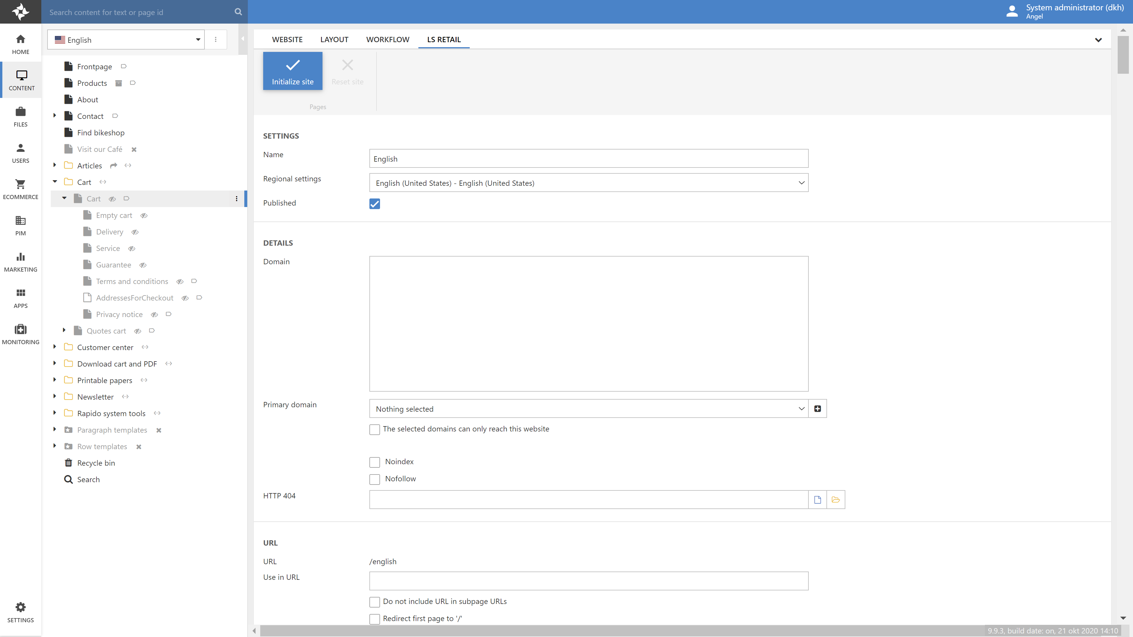
14. Edit Website -> LS Retail - > Initialize site.
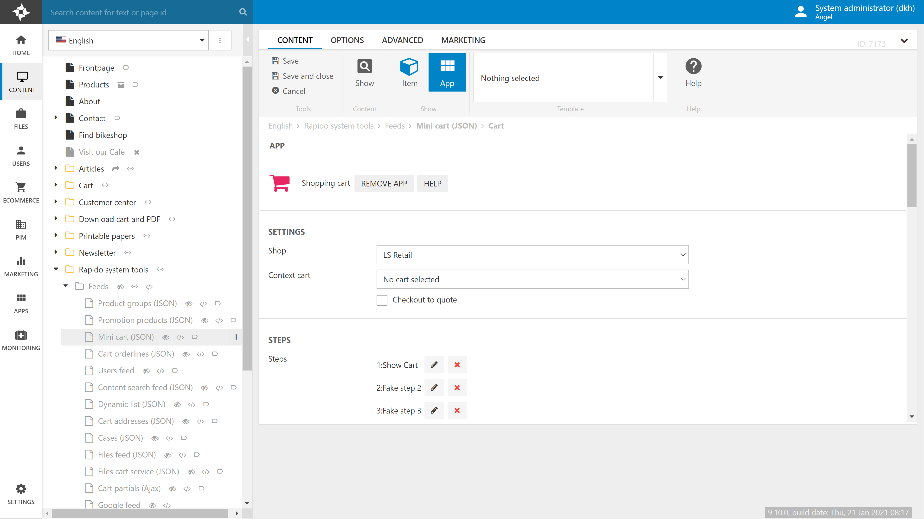
15. Content -> Rapido system tools -> Feeds -> Mini cart (JSON) -> Cart -> App. Set Shop to the shop you created in a previous step.
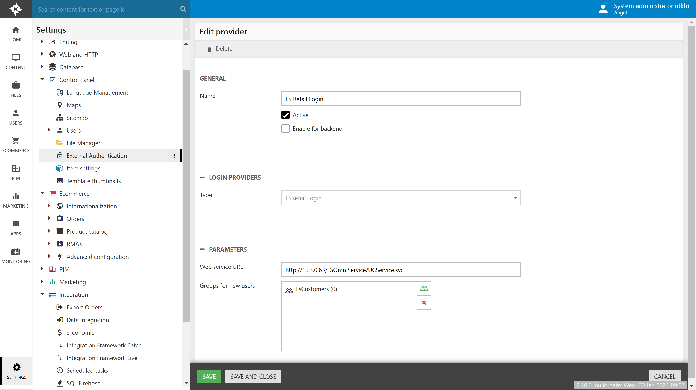
16. Settings -> Control Panel -> External Authentication -> LS Retail Login. Point Web service URL to Omni URL from step e.

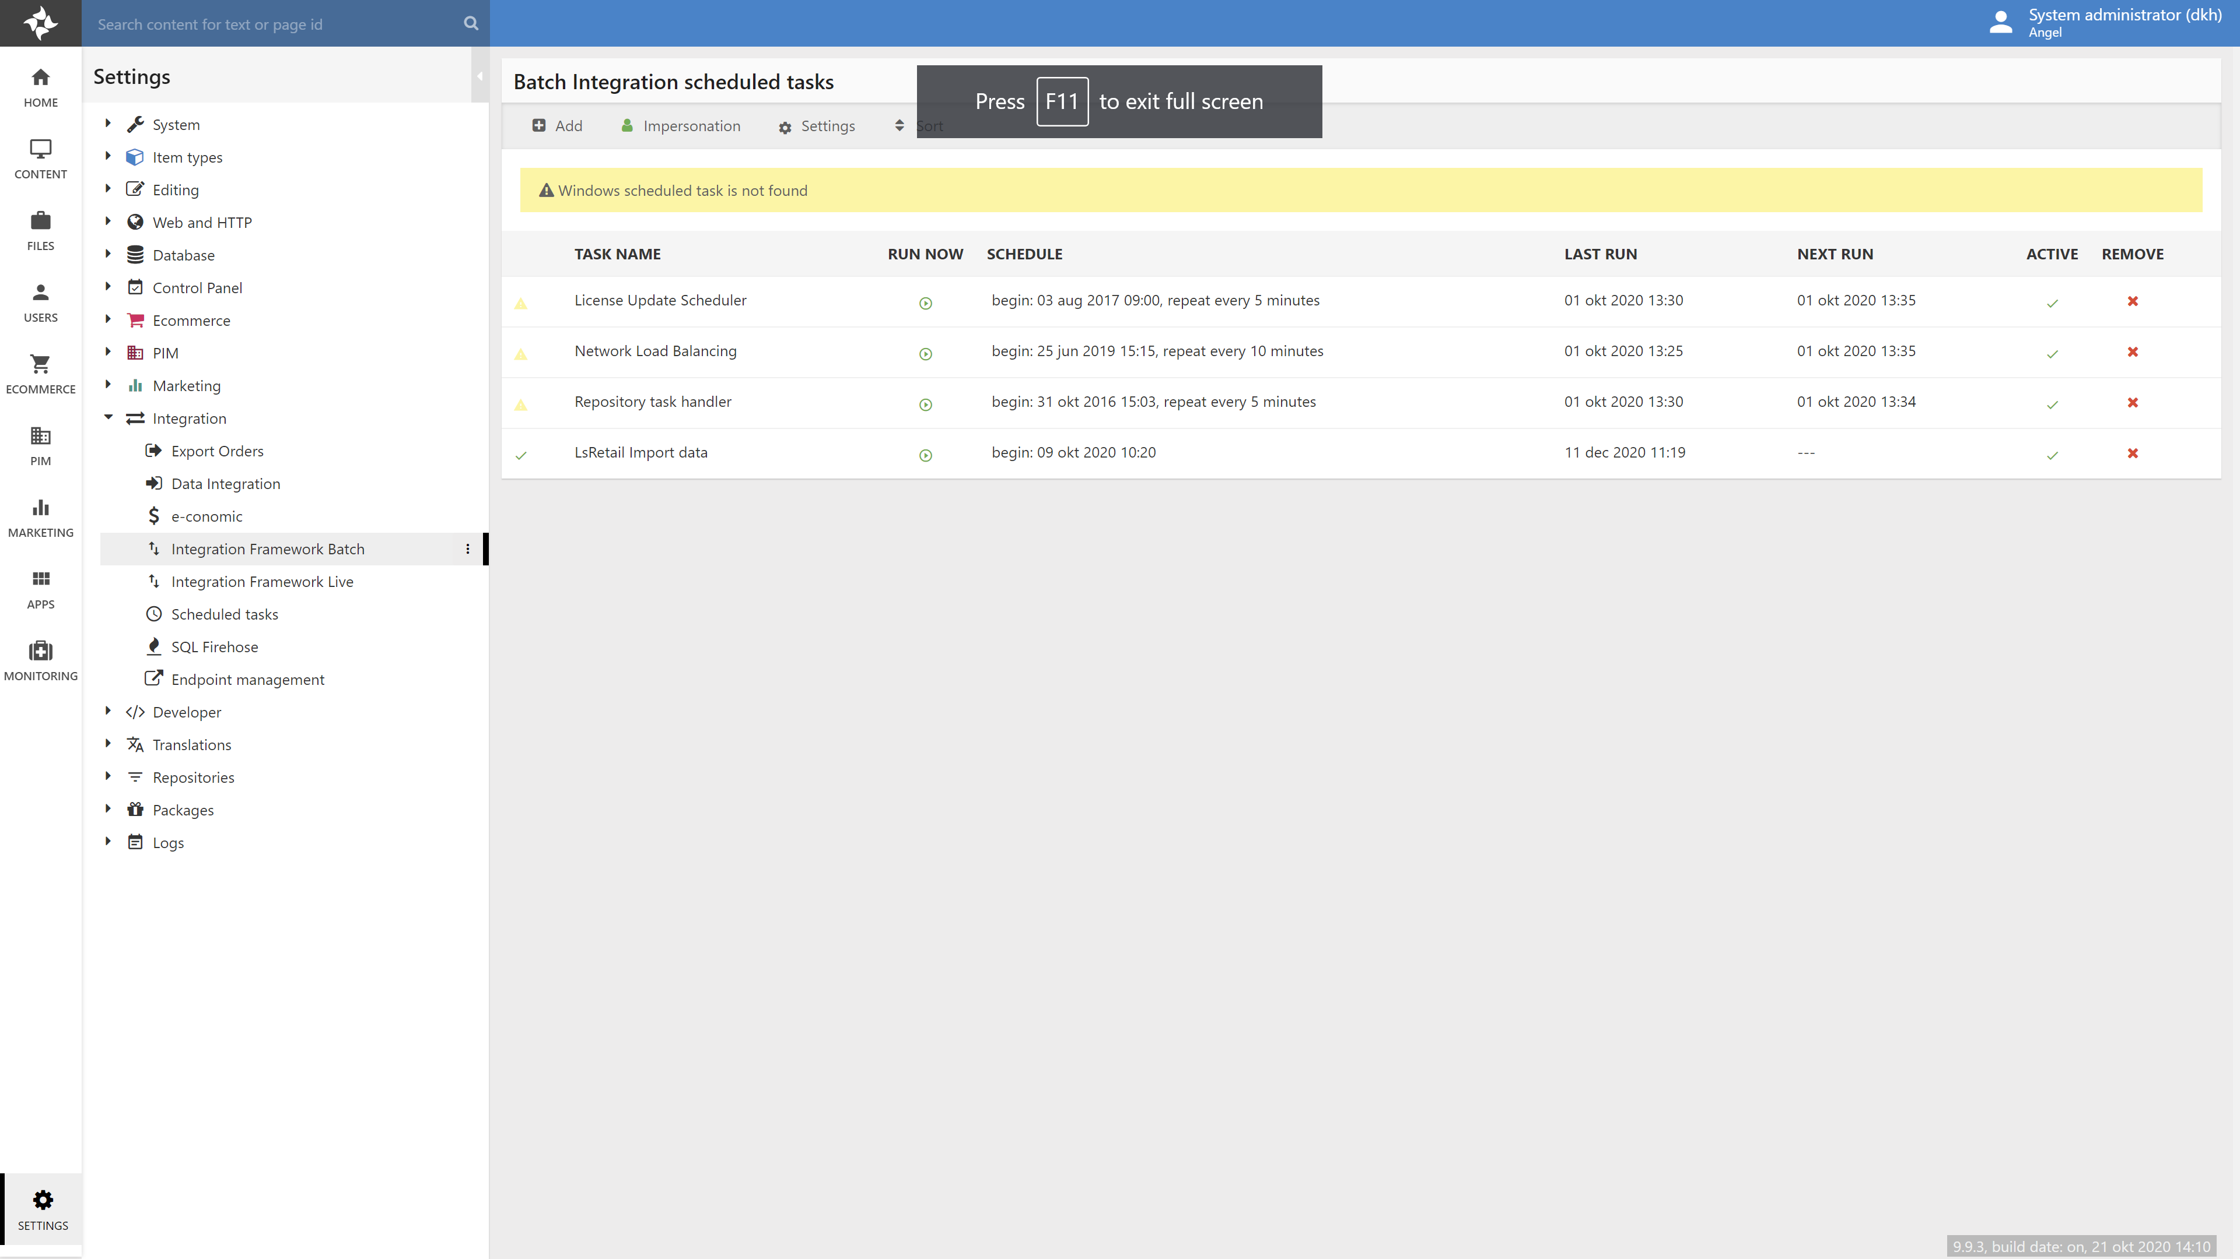
17. Last action, run the batch import.

Appendix: Known issues
- Member account: HTL-DEFAULT-GUEST causes import failure. Delete this account from LS Central

